LINUX FILE SYSTEM AND DIRECTORY STRUCTURE

OVERVIEW

In computing, a file system -- sometimes written filesystem -- is a logical and physical system for organizing, managing and accessing the files and directories on a device's solid-state drive ([SSD](https://www.techtarget.com/searchstorage/definition/SSD-solid-state-drive)), hard-disk drive ([HDD](https://www.techtarget.com/searchstorage/definition/hard-disk-drive)) or other media. Without a file system, the operating system ([OS](https://www.techtarget.com/whatis/definition/operating-system-OS)) would see only large chunks of data without any way to distinguish one file from the next. As data capacities increase, the efficient organization and accessibility of individual files becomes even more important in data storage.

WHAT IS A LINUX FILE SYSTEM

In Linux and Unix everything is a file. Directories are files, files are files, and devices are files. Devices are usually referred to as nodes; however, they are still files. Linux file system is generally a built-in layer of a [Linux operating system](https://www.javatpoint.com/what-is-linux) used to handle the data management of the storage. It helps to arrange the file on the disk storage. It manages the file name, file size, creation date, and much more information about a file.

DIRECTORY STRUCTURE

Files in Unix System are organized into multi-level hierarchy structure known as a **directory tree**. At the very top of the file system is a directory called “root” which is represented by a “/”. All other files are “descendants” of that root.

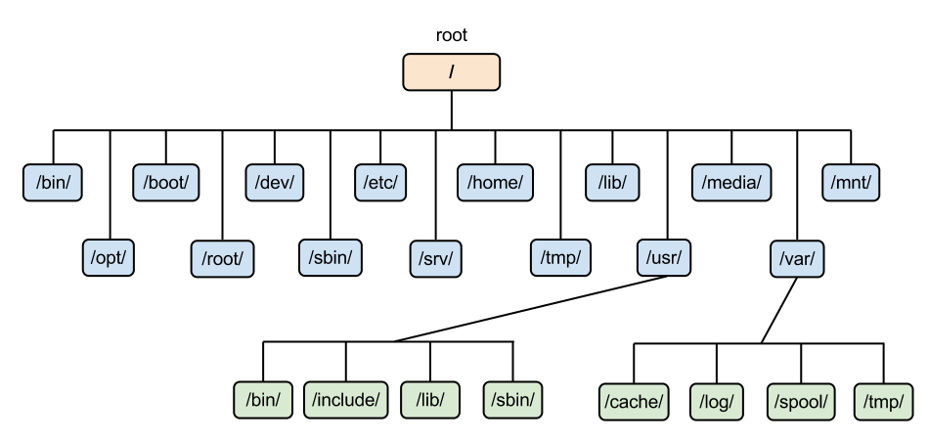

a typical linux file system

Now, because we have mentioned above a directory tree, lets explore a “tree package” to better understand it from the terminal.

we have to first install the package, depending on the distribution of linux you are currenting on, any of the below command should work:

sudo apt-get install tree

or

brew install tree

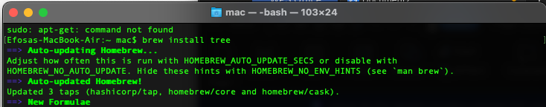

then, run :

tree -L 1 /

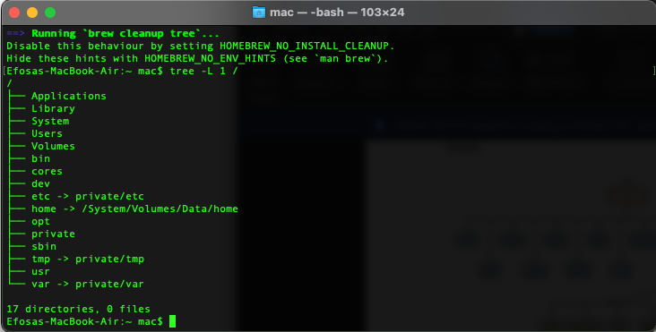

If you run **tree /**It’ll show you the tree of your whole filesystem,every single file you have in your OS and this can really take a while but fun. -**L 1**Is to only show level 1 and / to start at root.

Lets consider what each directory is used for:

****/ :****The slash / character alone denotes the root of the filesystem tree. The top-level directory of the filesystem. It must include all of the required executables and libraries required to boot the remaining filesystems. The following is a listing of common directories that are directly under the root (/) directory:

**/bin** - important binary applications which are generally needed by all users, basic tools for making and removing files and directories, moving them around, and so on.

**/boot** - boot configuration files, kernels, and other files needed at boot time. The static bootloader and kernel executables and configuration files required to boot a Linux computer. ****DO NOT TOUCH!****.

**/dev** - the device files. Contains file representations of peripheral devices and pseudo-devices. These are not device drivers, rather they are files that represent each device. For example, if you plug in a USB into your machine, a new device entry will automatically pop up here.

**/etc** - configuration files, startup scripts, etc. Gets its name from “et cetera” because it was the dumping ground for system files administrators were not sure where else to put. But now it contains most, if not all system-wide configuration files.

Again, if you are new to Linux, it may be best if you ****don’t touch**** too much in here until you have a better understanding of how things work.

**/home** - home directories for different users. Each user has a subdirectory in /home. It’s where you will find your users’ personal directories.

**/lib** - system libraries. Libraries are files containing code that your applications can use. Snippets of code that applications use to draw windows on your desktop, control peripherals, or send files to your hard disk

**/media** - automatically mounted (loaded) partitions on your hard drive and removable media such as CDs, digital cameras, etc.

**/mnt** - manually mounted filesystems on your hard drive

**/opt** - provides a location for optional (3rd party) applications to be installed. Also, often where software you compile ( you build yourself from source code and do not install from your distribution repositories) sometimes lands

**/proc** - special dynamic directory that maintains information about the state of the system, including currently running processes.It contains information such as CPU and the kernel your Linux system is running. As with */dev*, the files and directories are generated when your computer starts, or on the fly, as your system is running and things change.

**/root** - root user's home directory, pronounced "slash-root". It is the home directory for the root user; the system administrator. It is separate from the rest of the users’ home directories because, again, ****YOU ARE NOT MEANT TO TOUCH IT****.

**/sbin** - important system binaries similar to */bin*, but it contains applications that only the superuser (hence the initial *s*) will need. You can use these applications with the sudo command that temporarily concedes you superuser powers.

**/srv** - can contain files that are served to other systems. If you are running a web server from your computer, your HTML files would go into */srv/http* (or */srv/www*). If you were running an FTP server, your files would go into */srv/ftp*.

**/sys** - system files, yet another virtual directory like */proc* and */dev* and also contains information from devices connected to your computer.

**/tmp** - A place for temporary files, usually placed there by applications that you are running. Many systems clear this directory upon startup

**/usr** - means “Unix System Resources”and not user. Applications and files that are mostly available for all users to access are kept here.

**/var** - variable files such as logs and databases. MySQL, and other database files, web server data files, email inboxes, and much more.

Be sure to look into more files from <https://help.ubuntu.com/kubuntu/desktopguide/C/directories-file-systems.html> that are not been covered here.

Guess what guys!!!, thats just level one of the root directory. The above tree command tree / should have given you a clue into the dept of directories and subdirectories.

Thank you for reading this far, hope this is helpful.